**Assignment 3**

**Activity Diagram – Administrator Adds Software**

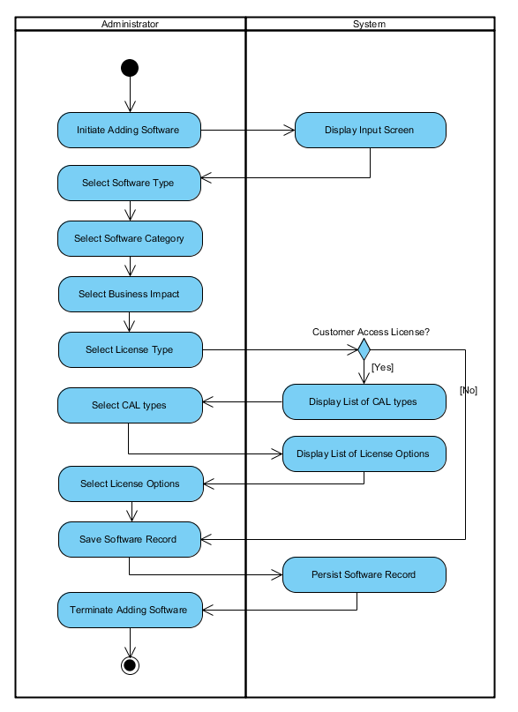

**Sequence Diagram - image**

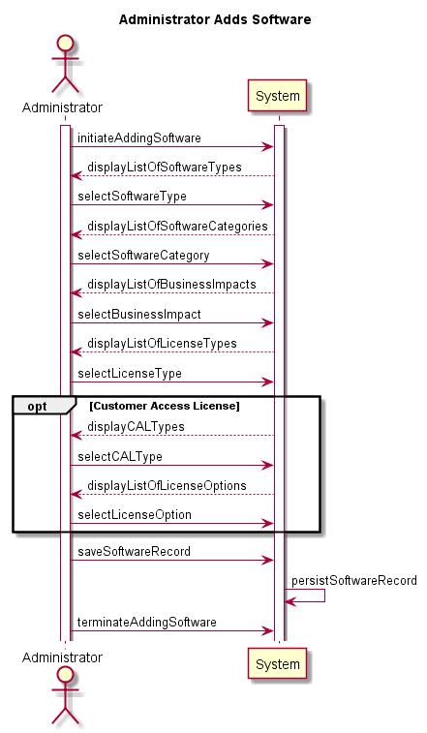

**Sequence Diagram - script**

' AdministratorAddsSoftware.txt

' PlantUML script to create a system sequence diagram

'

' Revision History:

' ycho, 2016.02.26: Created

@startuml

actor Administrator

participant System

activate Administrator

activate System

Title Administrator Adds Software

Administrator -> System : initiateAddingSoftware

System --> Administrator : displayListOfSoftwareTypes

Administrator -> System : selectSoftwareType

System --> Administrator : displayListOfSoftwareCategories

Administrator -> System : selectSoftwareCategory

System --> Administrator : displayListOfBusinessImpacts

Administrator -> System : selectBusinessImpact

System --> Administrator : displayListOfLicenseTypes

Administrator -> System : selectLicenseType

opt Customer Access License

System --> Administrator : displayCALTypes

Administrator -> System : selectCALType

System --> Administrator : displayListOfLicenseOptions

Administrator -> System : selectLicenseOption

end

Administrator -> System : saveSoftwareRecord

System -> System : persistSoftwareRecord

Administrator -> System : terminateAddingSoftware

@enduml